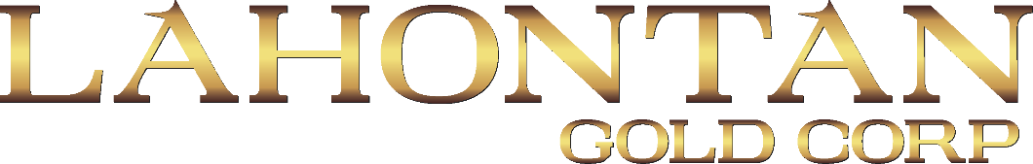

NEWS RELEASE TSX.V LG, OTCQB LGCXF

LAHONTAN MOBILIZES DRILL RIG TO SANTA FE

TORONTO, ON, May 8, 2023 – Lahontan Gold Corp. (TSXV:LG, OTCQB:LGCXF) (the "Company" or "Lahontan") is pleased to announce that it has mobilized a Boart Longyear MPD-1500 track-mounted reverse-circulation (“RC”) drill rig to its Flagship Santa Fe Mine, located in Nevada’s Walker Lane, a Tier One mining jurisdiction. Drilling is expected to commence the week of May 8, 2023. The Company has permitted a drilling program consisting of up to 11,000 metres of RC drilling designed to expand upon the project’s existing pit constrained gold and silver Resource (Indicated Mineral Resource of 1,112,000 oz Au Eq (grading 1.14 g/t Au Eq) and an Inferred Mineral Resource of 544,000 oz Au Eq (grading 1.00 g/t Au Eq), please see Santa Fe Project Technical Report*).

The initial phase of the 2023 drilling program will focus on Slab-Calvada Complex, with step-out drilling designed to expand upon the extensive oxide gold and silver Resources at Slab-Calvada (please see map below). Twenty RC drill holes are planned adjacent to the known gold and silver Resources, allowing the Company to tie-together the existing Resource pit shells, consolidating the individual Resources into a larger conceptual pit.

Kimberly Ann, Lahontan Gold Founder, CEO, President, and Director commented: “Lahontan is excited to embark on its 2023 drilling campaign. Our initial focus on the Slab-Calvada complex intends to build upon the tremendous success of our past drilling and grow oxide gold and silver resource ounces. We will fill-in between the individual gold and silver deposits at Slab-Calvada and also explore at depth where we still have not reached the bottom of oxide gold and silver mineralization”.
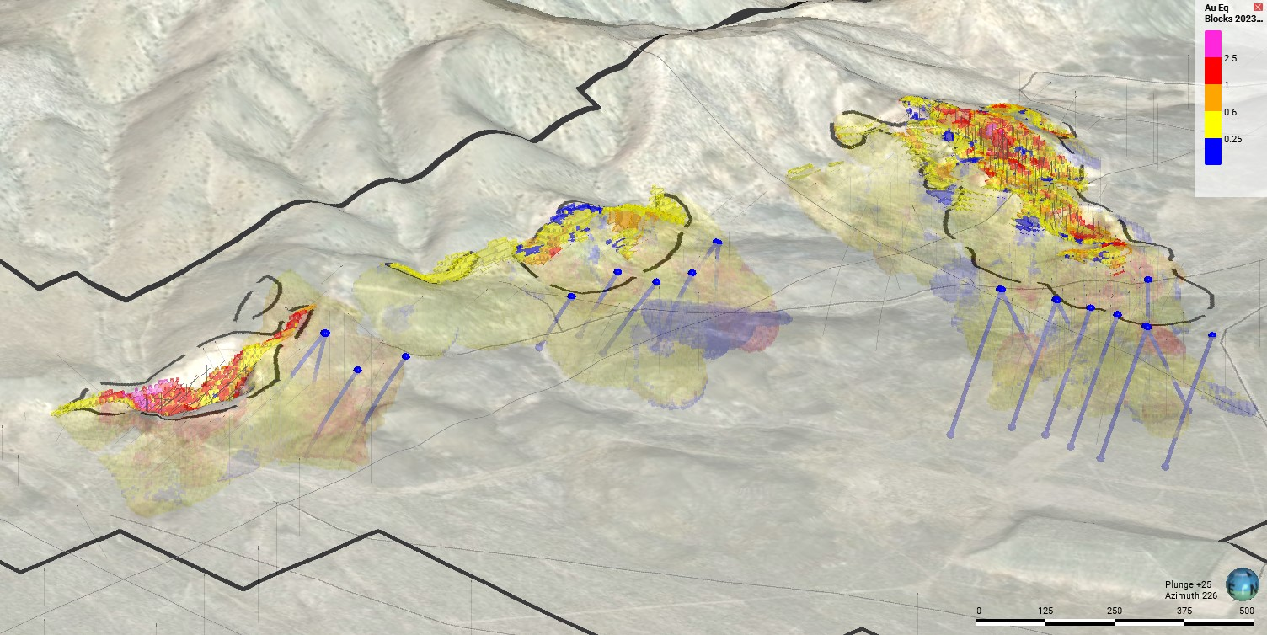
CALVADA CENTRAL
CALVADA
SLAB
Oblique view of the Slab-Calvada Complex looking southwest showing known gold and silver resource blocks, constraining pit shells (black), and planned 2023 RC drill holes (blue). Resource blocks are color-coded for grade.

About Lahontan Gold Corp.

Lahontan Gold Corp. is a Canadian mineral exploration company that holds, through its US subsidiaries, three top-tier gold and silver exploration properties in the Walker Lane of mining friendly Nevada. Lahontan’s flagship property, the 19 km² Santa Fe Mine, had past production of 345,000 ounces of gold and 711,000 ounces of silver between 1988 and 1995 from open pit mines utilizing heap-leach processing (Nevada Bureau of Mines and Geology, 1995). The Santa Fe Mine has an Indicated Mineral Resource of 1,112,000 oz Au Eq (grading 1.14 g/t Au Eq) and an Inferred Mineral Resource of 544,000 oz Au Eq (grading 1.00 g/t Au Eq), all pit constrained (Au Eq is inclusive of recovery, please see Santa Fe Project Technical Report*). The Company will continue to aggressively explore Santa Fe during 2023 and begin the process of evaluating development scenarios to bring the Santa Fe Mine back into production. Quentin J. Browne, P.Geo., Consulting Geologist to Lahontan Gold Corp., is the Qualified Person for the Company and approved the technical content of this news release. For more information, please visit our website: www.lahontangoldcorp.com
* Please see the Santa Fe Project Technical Report, Authors: Trevor Rabb and Darcy Baker, P. Geos. Effective Date: December 7, 2022, Report Date: March 2, 2023. The Technical Report is available on the Company’s website and SEDAR.

On behalf of the Board of Directors

Kimberly Ann

Founder, CEO, President, and Director

FOR FURTHER INFORMATION, PLEASE CONTACT:

Lahontan Gold Corp.
Kimberly Ann
Founder, Chief Executive Officer, President, Director

Phone: 1-530-414-4400
Email: Kimberly.ann@lahontangoldcorp.com

Website: www.lahontangoldcorp.com

Cautionary Note Regarding Forward-Looking Statements:

Neither TSX Venture Exchange nor its Regulation Services Provider (as that term is defined in policies of the TSX Venture Exchange) accepts responsibility for the adequacy or accuracy of this release.

Except for statements of historic fact, this news release contains certain "forward-looking information" within the meaning of applicable securities law. Forward-looking information is frequently characterized by words such as "plan", "expect", "project", "intend", "believe", "anticipate", "estimate" and other similar words, or statements that certain events or conditions "may" or "will" occur. Forward-looking statements are based on the opinions and estimates at the date the statements are made and are subject to a variety of risks and uncertainties and other factors that could cause actual events or results to differ materially from those anticipated in the forward-looking statements including, but not limited to delays or uncertainties with regulatory approvals, including that of the TSXV. There are uncertainties inherent in forward-looking information, including factors beyond the Company’s control. The Company undertakes no obligation to update forward-looking information if circumstances or management's estimates or opinions should change except as required by law. The reader is cautioned not to place undue reliance on forward-looking statements. Additional information identifying risks and uncertainties that could affect financial results is contained in the Company’s filings with Canadian securities regulators, which filings are available at www.sedar.com

